## 

|  |
| --- |
| **International School**  Đồ Án CDIO  **CMU-CS 447**    Interface Design  Version 1.0  Date: 05- April - 2025  Airline Reservation System  Submitted by  Nguyen Pham Anh Huong  Cao Minh  Le Minh Hieu  Nguyen Thi Thanh Huong  **Approved by**  **Capstone Project 1 - Mentor:**  Name Signature Date  Tinh, Le Van __________________04 - April- 2025 |

Table Contents

**PROJECT INFORMATION 4**

**DOCUMENT INFORMATION 5**

**REVISION HISTORY 6**

**1. INTRODUCTION 7**

1.1. PURPOSE OF DOCUMENT 7

1.2. INTENDED AUDIENCES 7

1.3. DOCUMENT OVERVIEW 7

**2. DETAILED INTERFACE DESIGN 8**

2.1. Homepage 8

2.2. Navbar 9

2.3. Footer 10

2.4. Booking plane ticket page 11

2.5. Flight Search Filters Specification 13

2.6 Login page 15

2.7 Register page 15

# PROJECT INFORMATION

Table 1 - Project Information

|  |  |  |  |
| --- | --- | --- | --- |
| **PROJECT INFORMATION** | | | |
| **Project Acronym** | ARS | | |
| **Project Title** | Airline Reservation System | | |
| **Project Web URL** |  | | |
| **Start Date** | 5-Apr - 2025 | | |
| **End Date:** | 24 - May - 2025 | | |
| **Lead Institution** | International School, Duy Tan University | | |
| **Project Mentor** | M.Sc Tinh, Le Van | | |
| **Scrum Master** | Minh, Cao | Minhcao05092004@gmail.com | 0905575080 |
| **Team Members** | Huong, Nguyen Thi Thanh | nguyennguyenkhanhquynh@gmail.com | 0358692336 |
| Huong, Nguyen Pham Anh | ahhuong312@gmail.com | 0774442236 |
| Hieu, Le Minh | lhieu20231@gmail.com | 0901942400 |

# DOCUMENT INFORMATION

|  |  |  |  |
| --- | --- | --- | --- |
| **DOCUMENT INFORMATION** | | | |
| **Document Title** | Interface Design | | |
| **Author(s)** | Group 3 | | |
| **Role** | Interface Design_v1.0 | | |
| **Date** | 5-Apr - 2025 | File name | Interface Design_v1.0 |
| **URL** | https://github.com/nnkq/myproject.git | | |
| **Access** | Project and CMU Program | | |

Table 2 - Document Information

# REVISION HISTORY

|  |  |  |  |  |
| --- | --- | --- | --- | --- |
| **Version** | **Person(s)** | **Date** | **Description** | **Approval** |
| 1.0 | All members | 5-Apr - 2025 | Initiate Interface Design Document | x |
|  |  |  |  |  |
|  |  |  |  |  |
|  |  |  |  |  |
|  |  |  |  |  |
|  |  |  |  |  |
|  |  |  |  |  |
|  |  |  |  |  |

Table 3 - Revision History

# INTRODUCTION

## PURPOSE OF DOCUMENT

This IDD of the ARS system has the following purpose:

* Document the design of user interface of functions of ARS
* Be the primary document driving the implementation of the user interfaces.
* Introduce interface design for the reader. Including the background, content information display, command buttons.

## INTENDED AUDIENCES

This IDD is intended for the following audiences:

* Technical reviewers including:
* Scrum Master
* Product owner
* Implementers, including:
  + Developers.
  + Testers.

## DOCUMENT OVERVIEW

This IDD is organized into the following sections:

* This document helps to better understand the interface of the Smart Dashboard Application System, detailed specification components and function of the Application.
* With this document, the development team can understand the structure and composition to create a consistent and complete system.
* Overview of the stages and modules of the software and create a complete interface.

# DETAILED INTERFACE DESIGN

## Homepage

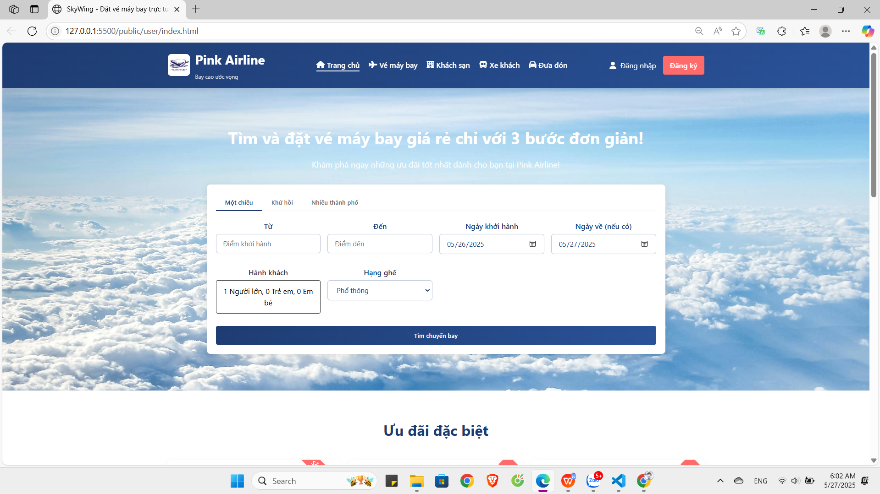

|  |  |  |  |  |
| --- | --- | --- | --- | --- |
| **Homepage** | | | | |
| **No.** | **Field name** | **Type** | **Require** | **Target** |
| 1 | Background |  | Background: #101522 |  |
| 2 | Heading | H1 tag | Font-size: 48px  Font-weight: 600  Color: #f7f8fa | Smart Dashboard Application |
| 3 | Subtitle | P tag | Font-size: 18px  Color: #a9b3c1 | Short introduction about ARS |
| 4 | Button | button | Background: #4b59f7  Padding: 10 20px  Color: #fff  Font-size: 16px; | Redirect to /about page |
| 5 | Thumbnail | image |  | logo.png |

## Navbar

### IN HOME PAGE



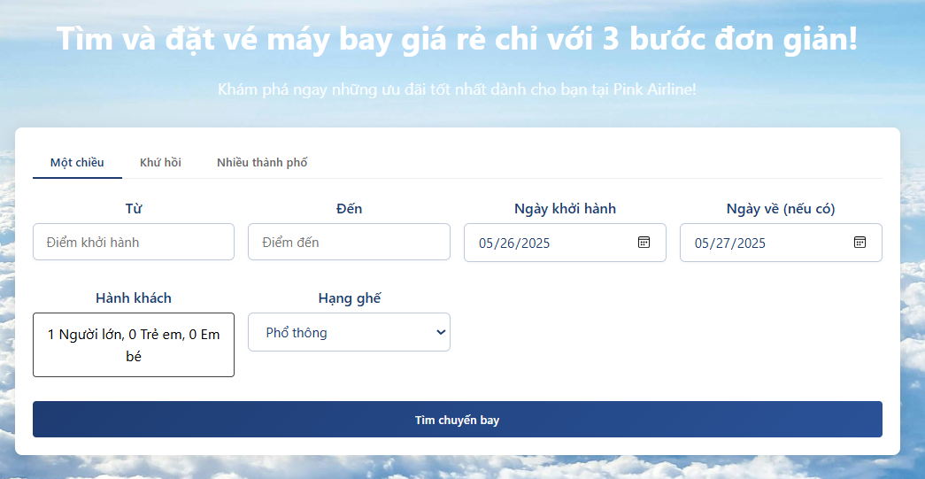

|  |  |  |  |  |
| --- | --- | --- | --- | --- |
| **Navbar** | | | | |
| **No.** | **Field name** | **Type** | **Require** | **Target** |
| 1 | Logo | image |  | logo.png |
| 2 | Menu | List | Height: 90px; Font-size: 19px; Font-family: “Source sans pro”. Responsive: max-width: 960px; | Home, Dashboard, About, Contact |

### IN AIRPLANE TICKET PAGE



|  |  |  |  |  |
| --- | --- | --- | --- | --- |
| **Navbar** | | | | |
| **No.** | **Field name** | **Type** | **Require** | **Target** |
| 1 | Logo | image |  | logo.png |
| 2 | Group Button | button | Width: 100px;  Height: 35px; | New, Save, Help, Example 1, Example 2 |

## Footer



|  |  |  |  |  |
| --- | --- | --- | --- | --- |
| **Footer** | | | | |
| **No.** | **Field name** | **Type** | **Require** | **Target** |
| 1 | Logo | image |  | logo.png |
| 2 | Credits | P tag | Font-size: 19px;  Font-family: “source sans pro”  Responsive: 960px | ARS-Team © 2020 |
| 3 | Github Link | Icon Button | Icon name: “FaGithub” | https://github.com/ARSteamdtu2020 |

## Booking plane ticket page

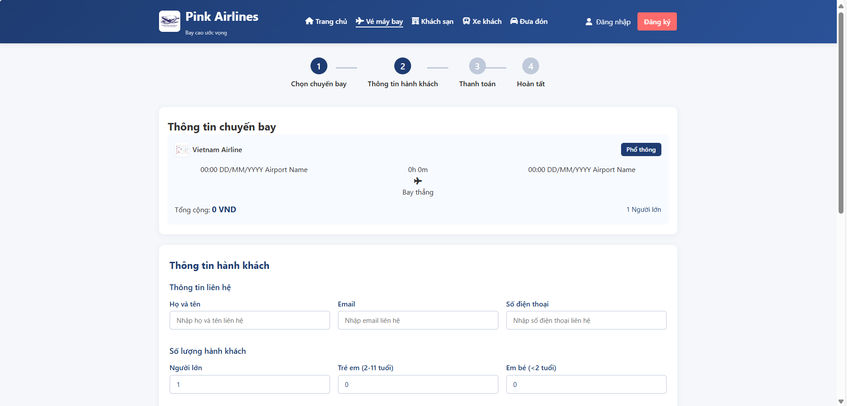

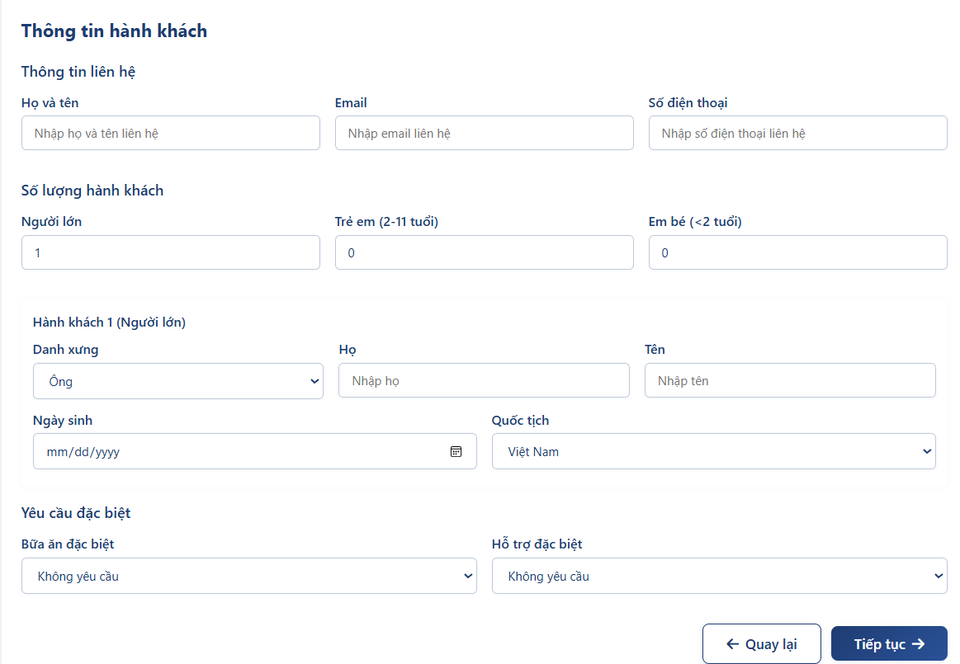

|  |  |  |  |  |
| --- | --- | --- | --- | --- |
| **Dashboard page** | | | | |
| **No.** | **Field name** | **Type** | **Require** | **Target** |
| 1 | Toolbar | div | Width: 185px  Height: full height |  |
| 2 | Info | div | Width: 320px |  |
| 3 | MashupContent | div | Width: 100vw - toolbar - info |  |

## Flight Search Filters Specification

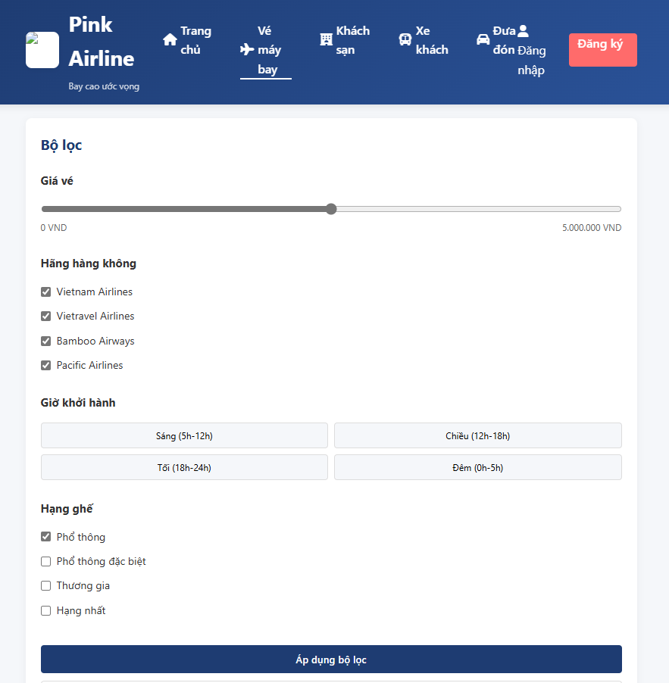

|  |  |  |  |  |
| --- | --- | --- | --- | --- |
| **Flight Search Filters Specification** | | | | |
| **No.** | **Field name** | **Type** | **Require** | **Target** |
| 1 | Price Range | Slider | Range: 0 - 5,000,000 VND, step: 50,000 | Default: 0-5,000,000 |
| 2 | Airlines Filter | Checkboxes | Vertical list with airline logos | Vietnam Airlines, Vietravel, Bamboo, Pacific |
| 3 | Departure Time | Checkboxes | Grouped by time periods | Morning, Afternoon, Evening, Night |
| 4 | Seat Class | Radio Buttons | Visual icons for each class | Economy, Premium Economy, Business, First Class |
| 5 | Apply Filters | Button | Pink background (#ff1493), white text | "Apply filter" |
| **Flight Results Specification** | | | | |
| **No.** | **Field name** | **Type** | **Require** | **Target** |
| 1 | Sort Options | Dropdown | Right-aligned, 12px font | Best Fit, Lowest Price, Earliest Flight |
| 2 | Flight Card | Card | Shadow effect, 16px padding | Airline logo, times, price |
| 3 | Flight Duration | Text | Gray color (#777) | "2h 15m" |
| 4 | Price | Text | Pink color (#ff1493), bold | "1,850,000 VND" |
| 5 | Select Button | Button | Outline style, pink border | "Select a trip" |

## 2.6 Login page

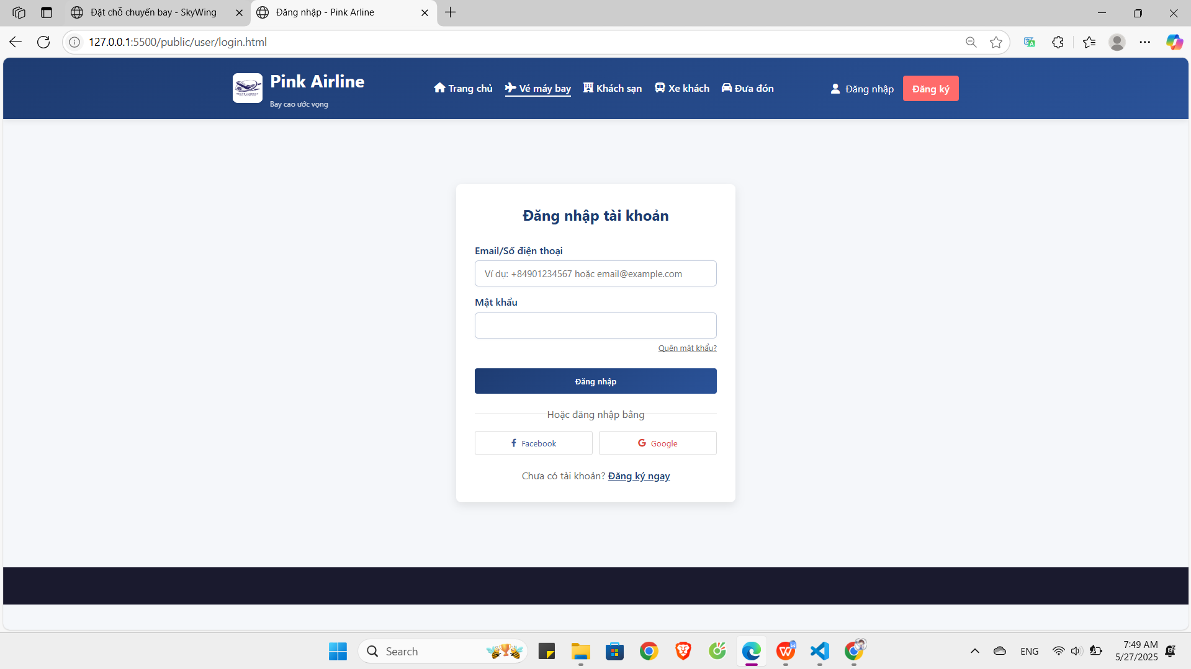

## 2.7 Register page

